Topic : Albania, our native land.
Political life of Albania through history.
Class : X^{C}

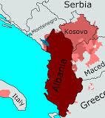

Prepared by :
Fatlinda Yzo

Objectives :

- We must recognize the Albanian political life all the way through history.
- We should know the importance of our native land.

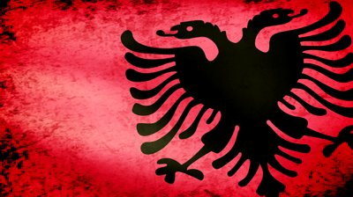

The Republic of Albania is located in the Balkan, bordering Greece on the South, the Republic of Macedonia on the East, Montenegro and Kosova on the North and Adriatic and Ionic seas to the West and Southwest.
Albanians are a native Balkan people, although their exact origin is unclear. The national ideology insists on an unequivocal ethnic relationship with the ancient Illyrians. As little is known about the Illyrians and there are no historical records referring to the existence of the Albanian people during the first millennium. Albanians entered recorded history in the second half of the eleventh century, and only in this age can one speak with any degree of certainty about the Albanian people as they are known today. The origin of the Albanians has been for some time a matter of dispute among historians. Most historians conclude that the Albanians are a population of the prehistoric Balkans, such as the Illyrians, Dacians or Thracians.

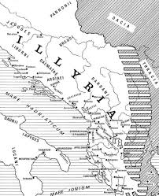

Illyrian territories

A part of Illyria in ancient times and later of the Roman Empire, Albania was ruled by the Byzantine Empire from 535 to 1204. An alliance of Albanian chiefs failed to halt the advance of the Ottoman Turks, and the country remained under at least nominal Turkish rule for more than four centuries.

George Kastrioti commonly known as Skanderbeg was a 15th-century Albanian nobleman, who had an immportant role in our war with Ottoman Turks.

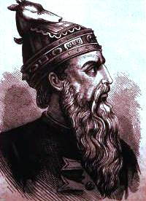
Albania proclaimed its independence on November 28, 1912. Largely agricultural, Albania is one of the poorest countries in Europe.

A battlefield in World War I, after the war it became a republic in which a conservative Muslim landlord, Ahmed Zogu, declared himself president in 1925 and king (Zog I) in 1928.

Skanderbeg

Ahmet Zogu the king of Albania
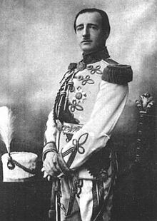
Zog I, King of the Albanians was the leader of Albania from 1925 to 1939, first asPresident (1925–1928) and then as King (1928–1939). Earlier he served as Prime Minister of Albania (1922–1924).On the same day as he was declared king (he was never technically crowned), he was declared Field Marshal of the Royal Albanian Army. He proclaimed a constitutional monarchy similar to the contemporary regime in Italy, created a strong police force, and instituted the Zogist salute (flat hand over the heart with palm facing downwards). Zog hoarded gold coins and precious stones, which were used to back Albania's first paper currency.He initially took the parallel name "Skanderbeg III" (Zogu claimed to be a successor of Skanderbeg.) The fascist government of Benito Mussolini's Italy had supported Zog since early in his presidency; that support had led to increased Italian influence in Albanian affairs.
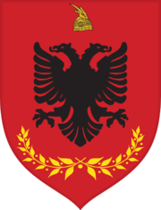

Albanian Royal Army.

Since 1945 till 1990 Albania was under communist regime. In these times Albania was leaded by Enver Hoxha.

Enver Hoxha
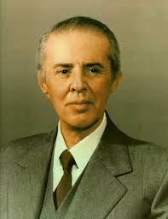
Enver Hoxha was the socialist leader of Albania from 1944 until his death in 1985, as the First Secretary of the Party of Labour of Albania.The 40-year period of Hoxha's rule was politically characterized by the elimination of the opposition, prolific use of the death penalty or long prison terms of his political opponents and evictions from homes where their families lived and their internment in remote villages that were strictly controlled by police and the secret police .His rule was also characterized by Stalinist methods to destroy his associates who threatened his own power.

He focused on rebuilding the country which was left in ruins after World War II, building Albania's first railway line, eliminating adult illiteracy and leading Albania towards becoming agriculturally self-sufficient.
Hoxha's government was characterized by his proclaimed firm to declare to anti-revisionist Marxism–Leninism from the mid-1970s onwards.After some years he had good relations with China but later they had a conflict. All albanians trust in his word and no one can discuss his law.

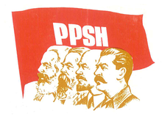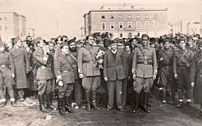
Symbol of the Party of Labour of Albania. Enver Hoxha following the liberation of Tirana in 1944.

On 9 April 1985, he suffered a massive ventricular fibrillation. All efforts to reverse it failed, and he died early on the morning of 11 April 1985. Hoxha's death left Albania with a legacy of isolation and fear of the outside world. Despite some economic progress made by Hoxha, the country was in economic stagnation; Albania had been the poorest European country throughout much of the Cold War period. Elections in March 1991 gave the Communists a decisive majority. But a general strike and street demonstrations soon forced the all-Communist cabinet to resign. In June 1991, the Communist Party of Labor renamed itself the Socialist Party and renounced its past ideology. The opposition Democratic Party won a landslide victory in the 1992 elections, and Sali Berisha, a former cardiologist, became Albania's first elected president. The following year, ex-Communists, including Ramiz Alia and former prime minister Fatos Nano, were imprisoned on corruption charges. But Albania's experiment with democratic reform and a free-market economy went disastrously awry in March 1997, when large numbers of its citizens invested in shady get-rich-quick pyramid schemes. When five of these schemes collapsed in the beginning of the year, robbing Albanians, they rage turned against the government. Sali Berisha is a Prime Minister from 2005 to 2013. He was also the leader of the Democratic Party of Albania twice, from 1991 to 1992 and then again from 1997 to 2013. (To date, Berisha is the longest-serving democratically-elected leader and the only President of Albania elected to a second term.)
Ilir Meta, elected prime minister in 1999, rapidly moved forward in his first years to modernize the economy, privatize business, fight crime, and reform the judiciary and tax systems. He resigned in Jan. 2002, frustrated by political infighting. In June 2002, former general Alfred Moisiu was elected president, endorsed by both the Socialists (headed by Fatos Nano) and the Democrats (led by Sali Berisha), in an effort to end the unproductive political fractiousness that has stalemated the government.
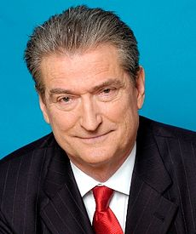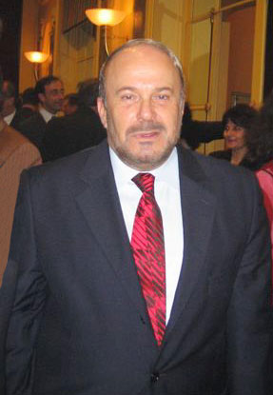
Sali Berisha Fatos Nano
The political duel between Nano and Berisha continued, however, and little improvement was evident in the standard of living for Albanians. In 2005 elections, Berisha replaced Nano, who had been appointed by Moisiu in 2002 as prime minister.

Bamir Topi, a scientist and senior member of Berisha's Democratic Party, was elected president by parliament in July 2007. Albania joined NATO in May 2009 and later in the month applied for membership in the European Union. In July 2009's elections, the closest since 1990, Berisha's center-right coalition narrowly defeated the opposition socialists, who were led by Edi Rama. The opposition disputed the results and accused Berisha of voter intimidation. After three failed attempts to elect a president, the parliament finally succeeded on June 11, 2012, when Interior Minister Bujar Nishani was elected with 73 votes of the 140 seats. Flamur Noka was named new interior minister and Edmond Panariti became foreign minister.
Sali Berisha, prime minister since 2005, was defeated in his third bid for the office. General elections held on June 23, 2013, resulted in victory for Edi Rama and his opposition Socialist Party, 53% to 36%. Berisha conceded defeat and announced his intention to step down from leadership of the Democratic Party, while Rama celebrated his victory and reiterated his goal to secure EU membership for Albania.
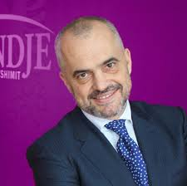
Edi Rama, premier of Albania.

A famous poet said : “Some say 'I am Turk,' others 'I am Latin,' / Some 'I am Greek,' others 'I am Slav,' / But you are brothers, all of you, my hapless people! .... Awaken, Albania, wake from your slumber, / Let us all, as brothers, swear a common oath / Not to look to church or mosque, / The faith of the Albanian is Albanianism!"
This expression tells us that regardless of all we have to be united with each-other.
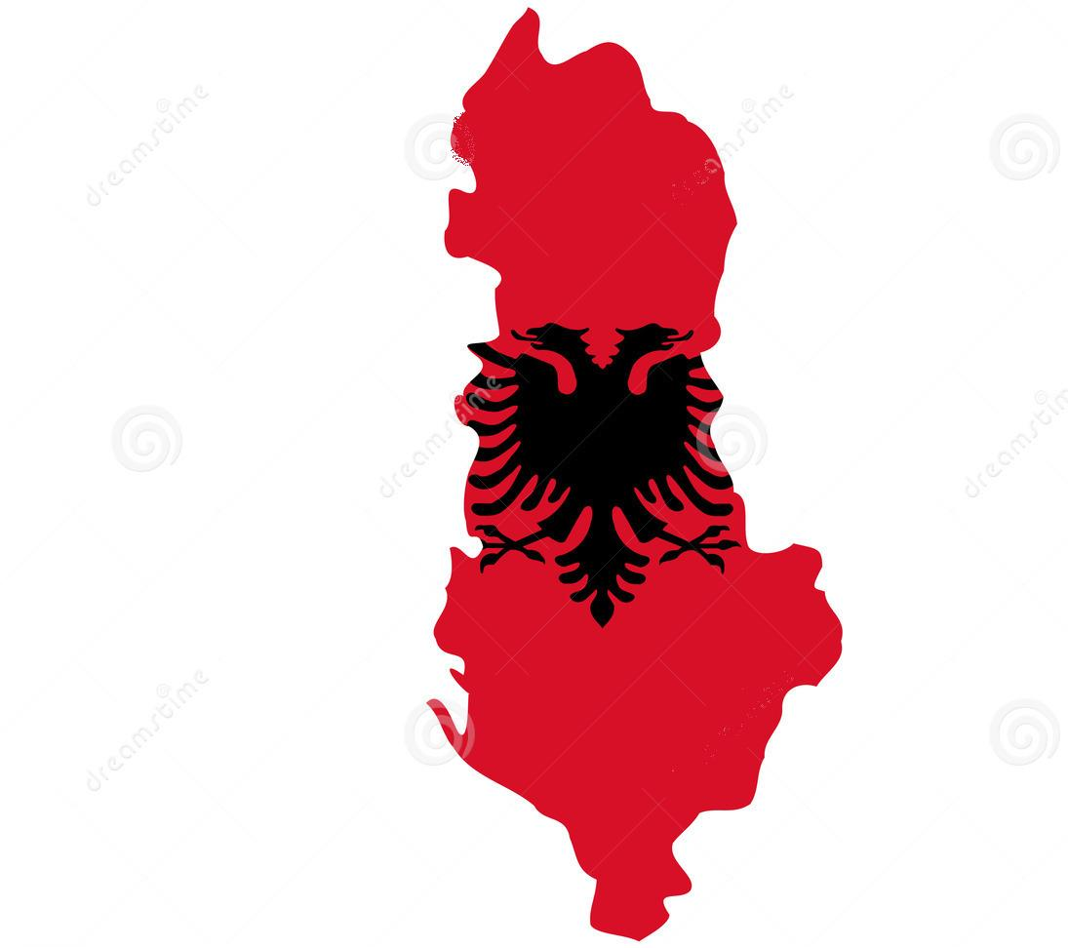
Keep calm and love Albania!

